PL/SQL Exercise-1 Control Structures : by Sahil Singh

Customers Table:

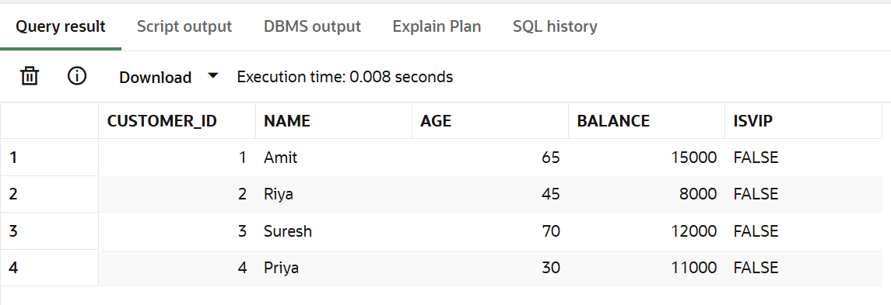

Loans Table:

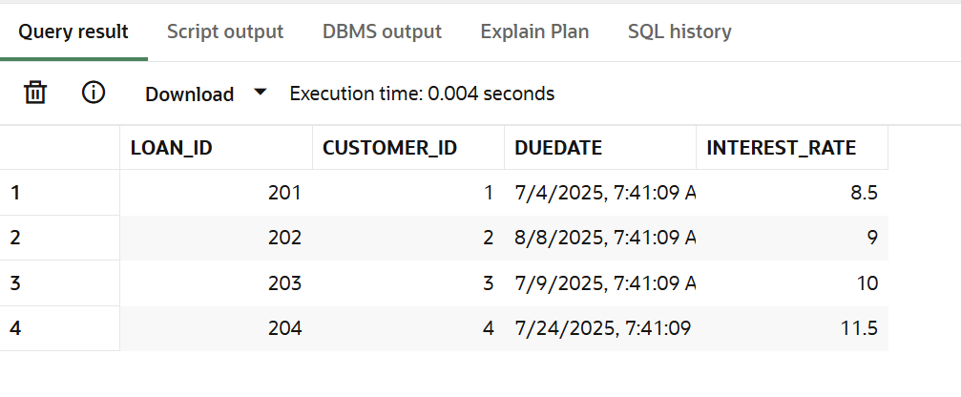

## Scenario 1: Discount for Senior Citizens

Apply a 1% discount to the loan interest rates for customers above age of 60 years.

BEGIN

  FOR rec IN (

    SELECT l.Loan_ID

    FROM Customers c

    JOIN Loans l ON c.Customer_ID = l.Customer_ID

    WHERE c.Age > 60

  )

  LOOP

    UPDATE Loans

    SET Interest_Rate = Interest_Rate - (Interest_Rate * 0.01)

    WHERE Loan_ID = rec.Loan_ID;

    DBMS_OUTPUT.PUT_LINE(' 1% discount applied to Loan_ID: ' || rec.Loan_ID);

  END LOOP;

  COMMIT;

END;

Output:

Loans:

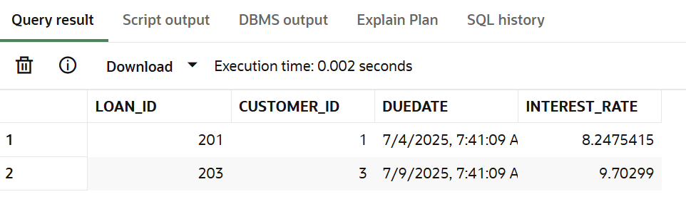

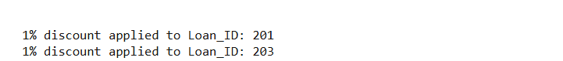

## Scenario 2: VIP Status

Set IsVIP = TRUE for customers with a balance more than 10,000.

BEGIN

  FOR rec IN (

    SELECT Customer_ID

    FROM Customers

    WHERE Balance > 10000

  )

  LOOP

    UPDATE Customers

    SET IsVIP = 'TRUE'

    WHERE Customer_ID = rec.Customer_ID;

    DBMS_OUTPUT.PUT_LINE('Customer_ID ' || rec.Customer_ID || ' marked as VIP.');

  END LOOP;

  COMMIT;

END;

Output:

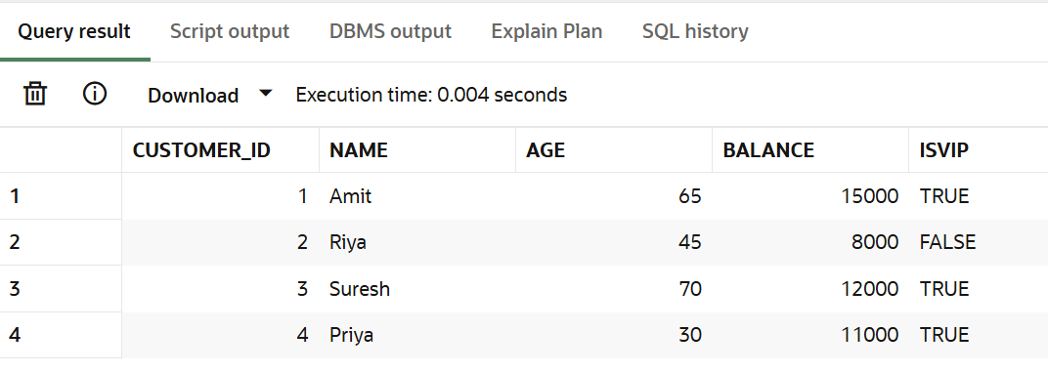

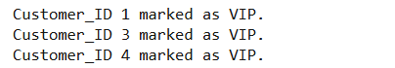

## Scenario 3: Loan Due Date Alert

reminder for customers whose loans are due within the next 30 days.

BEGIN

DBMS_OUTPUT.PUT_LINE('Loan Payment Reminders (due within 30 days) ');

FOR rec IN (

SELECT Loan_ID, Customer_ID, DueDate

FROM Loans

WHERE DueDate BETWEEN SYSDATE AND SYSDATE + 30

)

LOOP

DBMS_OUTPUT.PUT_LINE('Reminder: Loan_ID ' || rec.Loan_ID ||

' for Customer_ID ' || rec.Customer_ID ||

' is due on ' || TO_CHAR(rec.DueDate, 'DD-MON-YYYY'));

END LOOP;

END;

Output:

